

Auto Tab Numbering

**Installation Guide**

January 2015

**AUTO TAB NUMBERING PX**

Installation Guide



[**Xavor Corporatio**](http://www.xavor.com/)**n**

8925 Irvine Research Drive

Irvine, CA 92618, USA

Phone +1.949.529.7372 • Fax +1.949.250.4391



Copyright © 2015 Xavor Corporation

Contents

Overview 4

1. Installation Tasks Overview 4

2. Package Contents 4

Pre-Requisites 5

1. Apache Tomcat Requirement 5

2. Java Requirement 5

3. Agile PLM Account, Classes and privileges 5

Installation 7

1. Copy package Contents and configure properties 8

2. Deploy Application on the Apache Tomcat Server (6.0 or above) 9

2.1 Stop Tomcat 9

2.2 Copy files to Tomcat 9

2.3 Start Tomcat 10

3. Adding to Tools Menu in Agile 11

4. Verify Installation 12

# Overview

This section provides an overview of tasks to be performed for Installation and Setup on a Windows Server.

## Installation Tasks Overview

Section

1

The installation process has following sequence of steps. These will be subsequently described in detail in the following sections:

* Check system pre-requisites
* Create Environment Variable (Windows)
* Deploy the AutoTabNumbering war file to the Tomcat server.
* Test that the application works

## 2. Package Contents

Release package (.zip) should contain:

|  |  |  |  |
| --- | --- | --- | --- |
| **#** | **Content** | **Type** | **Description** |
| **1.** | Documents\ | FOLDER | Installation Guide |
| **2.** | Dependencies \ | FOLDER | Agile version specific jars |
| **3.** | Configurations\ | FOLDER | Properties file |
| 3 |  |  |  |
| **4.** | WAR\ | FOLDER | Application WAR file |
|  |  |  |  |

|  |  |  |
| --- | --- | --- |
|  |  |  |
|  |  |  |
| Pre-Requisites | Section |  |
| This section lists the System Requirements and Pre-requisite steps and checks for Installation. | 2 |  |
|  |  |
|  |  |  |

## Apache Tomcat Requirement

Process Extension (PX) will be installed on the **Tomcat Server 6.x or above**.

You will need to access the directory where tomcat is installed.

## Java Requirement

**JRE 1.6 or above** mustbe pre-installed on the server.

# Installation

This section provides steps to install configure and verify Installation. The high level steps include:

1. Copy Package Contents and configure properties
2. Deployment of WAR on Tomcat Server
3. Adding PX to Tools menu
4. Verification

Section

3

|  |
| --- |
| * Pre-Requisites mentioned in Section 2 of this document must be checked before proceeding with installation. * Paths stated in the documentation use Windows style notation. Please change on Unix platform. |

## Copy package Contents and configure properties

Please follow the below steps for setting up package contents:

1. Unpack **Release Package (.zip)** to any file system location for use during installation.
2. Create a folder with any name at manageable file system location (e.g. C:\AgilePXConfig)
3. Copy the following files from **Configurations** folder of package to the folder (created in step 2 above).
4. AutoTabNumbering.properties

* Open the file in notepad and configure your server URL in property ***agileUrl.***
* Number of digits in Tab Number is also configurable, you can modify it by changing value of property ***TabNumberLength.***
* Tabs generally start with “01” but this attribute is also configurable and can be modified by changing value of property ***FirstTabNumber.***

1. Create an environment variable named **AgilePXConfig** and provide path of the folder (created in step 2 above) as value.

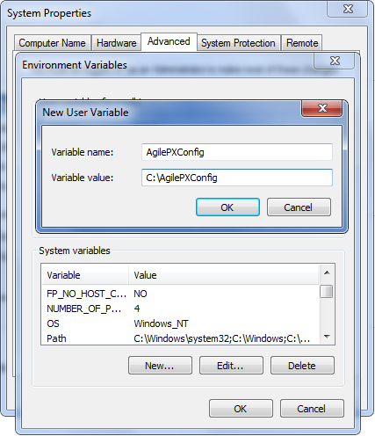

## Deploy Application on the Apache Tomcat Server (6.0 or above)

Below are the steps specific to deploy application to Tomcat Server:

|  |
| --- |
| * The steps mentioned below are for a simple deployment. The process may vary for different web servers |

### Stop Tomcat

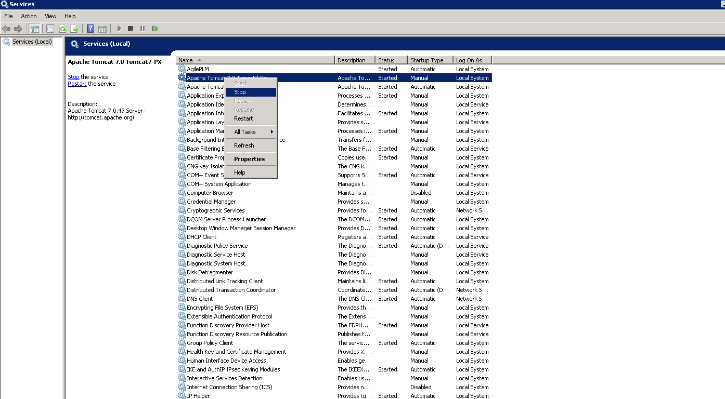Open window services and stop tomcat.

### Copy files to Tomcat

* Copy following from WAR folder to <Tomcat>/webapps

1. AutoTabNumbering.war

* Copy following jars from Dependencies/lib to <<tomcat>>/lib folder

1. AgileAPI.jar
2. log4j.jar

### C:\Users\msaeed\Desktop\screens 6 feb\16.png Start Tomcat

## Adding to Tools Menu in Agile

* + Agile Process Extension would have to be configured to launch AutoTabNumbering from Tools menu dropdown list.
  + Navigate to Admin -> Data Settings -> Process Extensions in Agile Java Client. Click Create New. Enter Name/API Name. Select type as URL and provide the URL in Address field as shown below.

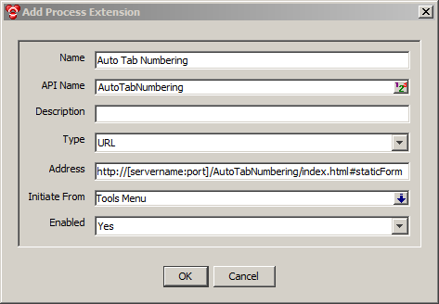

## Verify Installation

* Navigate to: http://<Serveraddress>:< Tomcat port>/AutoTabNumbering/ index.html#staticForm
* E.g. [http://agile933.xavor.com:8081/](http://agile933.xavor.com:8081/ETR/) AutoTabNumbering/index.html#staticForm. You should be able to view the following screen

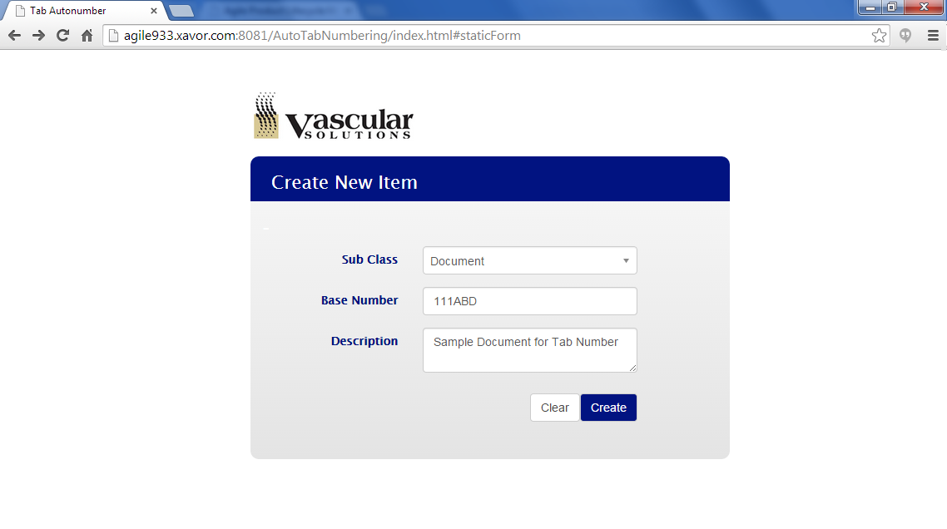

|  |  |  |
| --- | --- | --- |
|  |  |  |

--This page intentionally left blank--